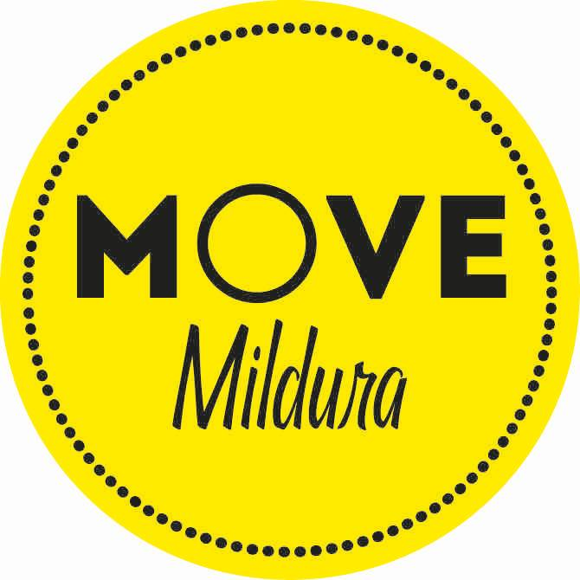

Are you competitive?

No

Cycling, triathlon, athletics, rowing, swimming and many, many more

Golf, walking, gym, home exercises, swimming, and many more

Boot camp, group exercise classes, hiking group and many more

Group Activities

Yes

Individual Sports

Yes

No

Football, Netball, Basketball, Soccer, baseball, cricket, just to name a few

Team Sports

Individual Activities

Yes

Do you work well with other?

No

Do you work well with other?